Competitive Shooters of Lake Norman 2025 Club Championship
COURSE DESIGNER: Ike Starnes
START POSITION: See written stage briefings.
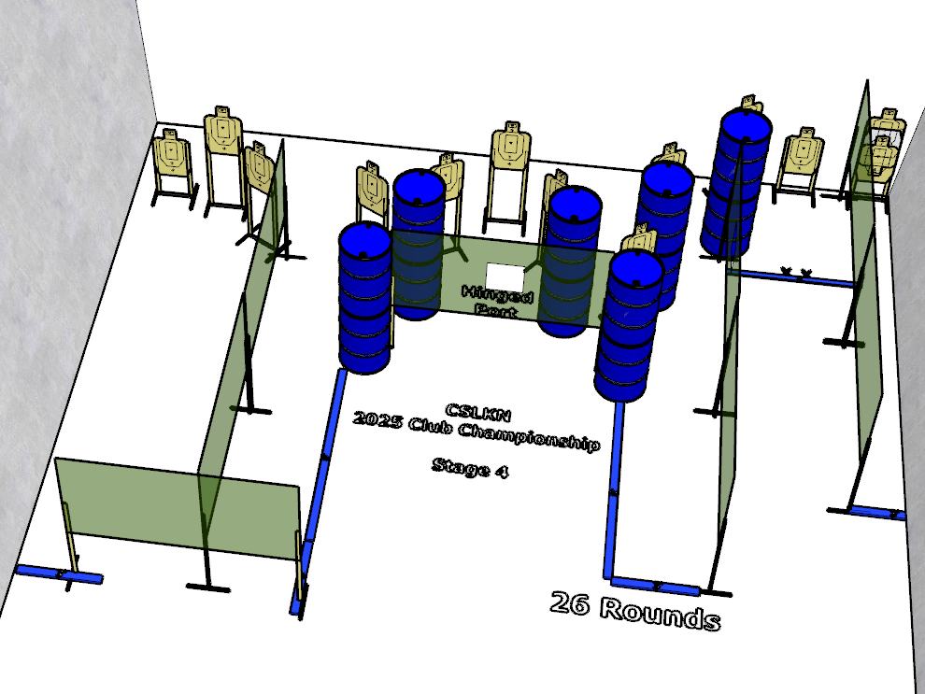

Written Stage Briefing:

Stage 4 – We’re on a mission from God - is a 26-round, 130 point, Comstock Course. There are 13 cardboard targets and some noshoots. The best 2 hits per cardboard target will be scored.
Handgun start position Both feet on Xs. The handgun is loaded and holstered.
PCC start position Both feet on Xs. PCC is loaded with stock touching belt.
On the audible start signal, engage targets from within the shooting area.

